Guernsey Padel Club

Type of membership required
Membership is for a minimum of 12 months

Membership (please tick)

[ ] Single £50.00 per month

[ ] Joint GTC and Padel £41.00 per month

[ ] Single Corporate £41.00 per month

[ ] Family £75.00 per month

[ ] Junior (under 18) £160.00 per year

Pay-and-Play Rates
Off Peak - £ 8 per person per hour
Peak - £ 10 per person per hour
Four players are required to play Padel

Please note:
Off Peak times are 9.00am - 6.00pm
Monday – Friday
& 1.00pm – 6.00pm at weekends

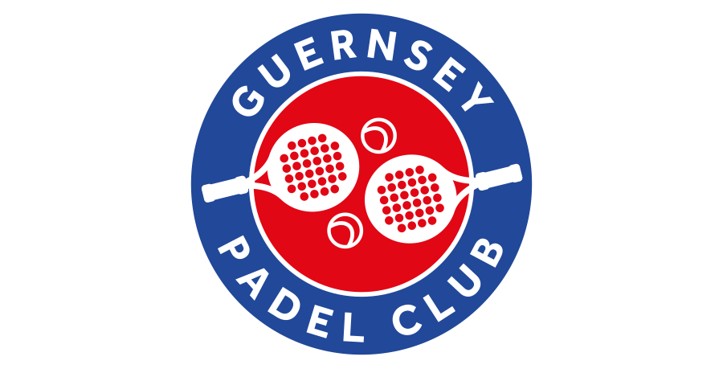

Full name(s) of applicants:

Mr/Mrs/Miss

Full Name

Date of birth:

Address:

Tel. No:

Mobile:

Email:

Further Family details:

Mr/Mrs/Miss/Mstr:

Date of birth:

Mr/Mrs/Miss/Mstr:

Date of birth:

Mr/Mrs/Miss/Mstr:

Date of birth:

I confirm that I wish to become a member of the
Guernsey Padel Club at Longcamps.
I agree to abound by the Rules of the Club

Signature...........................................................

Amount enclosed £..................................

Cheques made payable to Guernsey Padel Club

We may share your name, phone number and email address with other members of the Guernsey Padel Club in order to arrange suitable games/matches as a legitimate interest to those relevant parties and to the Club. Your information will be held on a secure booking software that is provided by a UK-based company.
In the event of you ceasing your membership with the Club your information will be deleted from our records within 3 months.
Your information will not be passed to any other outside parties.
If you give your consent for your data to be used in this way please tick the box and sign below.

[ ] ........................................................

For further information on
Membership, classes and lessons
Please call 712182 or
Follow us on facebook.
www.guernseypadelclub.gg

